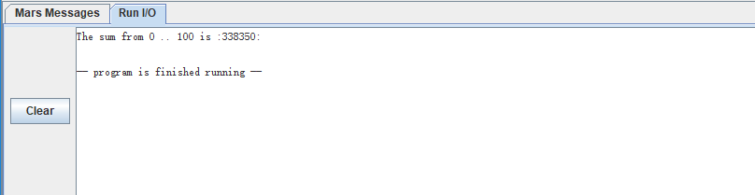

1. The sum from 0 .. 100 is :338350:

-- program is finished running –



1. The value of $t7 is 0x00002710, in decimal is 10000
2. I set a breakpoint on “mul $t7, $t6, $t6” which equals to $t7 = $t6 \* $t6. After executer that one instruction, the register $t7 has changed as a result. This instruction set $t7 to the square of $t6. Every time we run the loop, $t6 will be increased by one, and $t7 will be set for a new value. In the first time when we run the project, $t6 is 0 so $t7 has no change due to the square of 0 is 0.

After execute one step after the breakpoint, the register lo, $t7 and pc have changed. Every time I run that one step, pc increases by 4, $t7 equals to the square of $t6, and lo equals to $t7.